1. 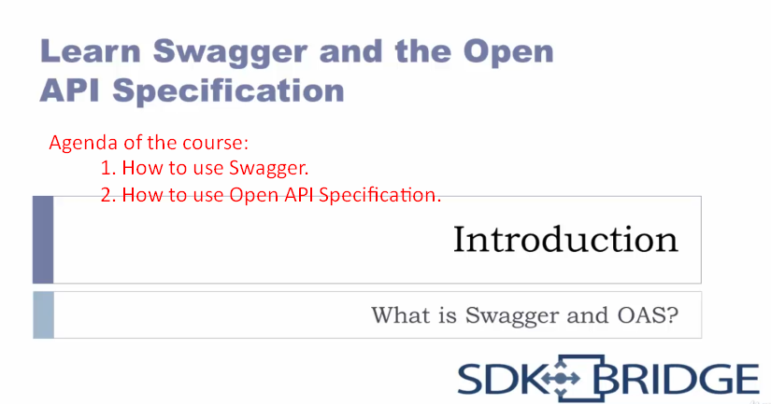
2. **Swagger**:
   1. A set of tools that help you create and use API definition, including the ability to automatically generate documentation for APIs.
3. 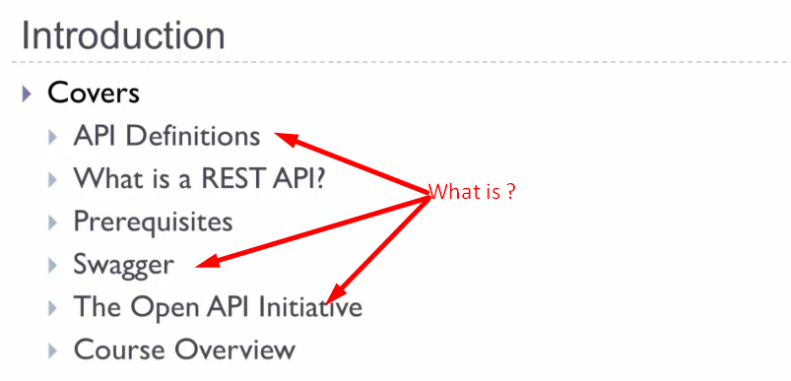
4. 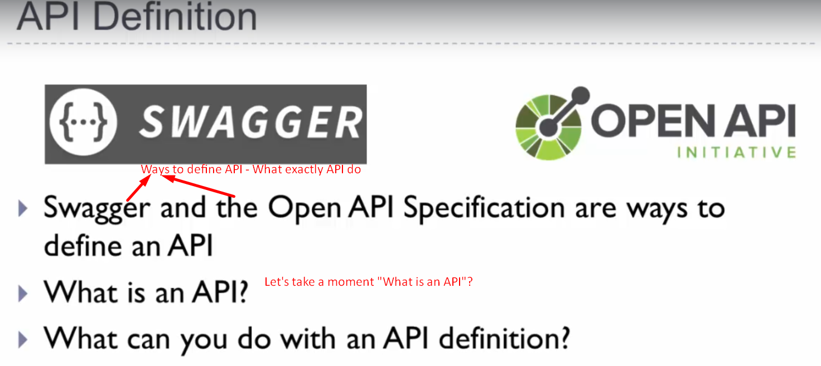
5. 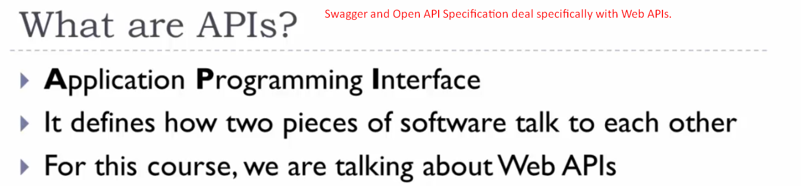
   1. There are many types of API.
   2. But, the swagger and Open API Specification specifically deal with Web APIs.
6. **How Web APIs work**?  
   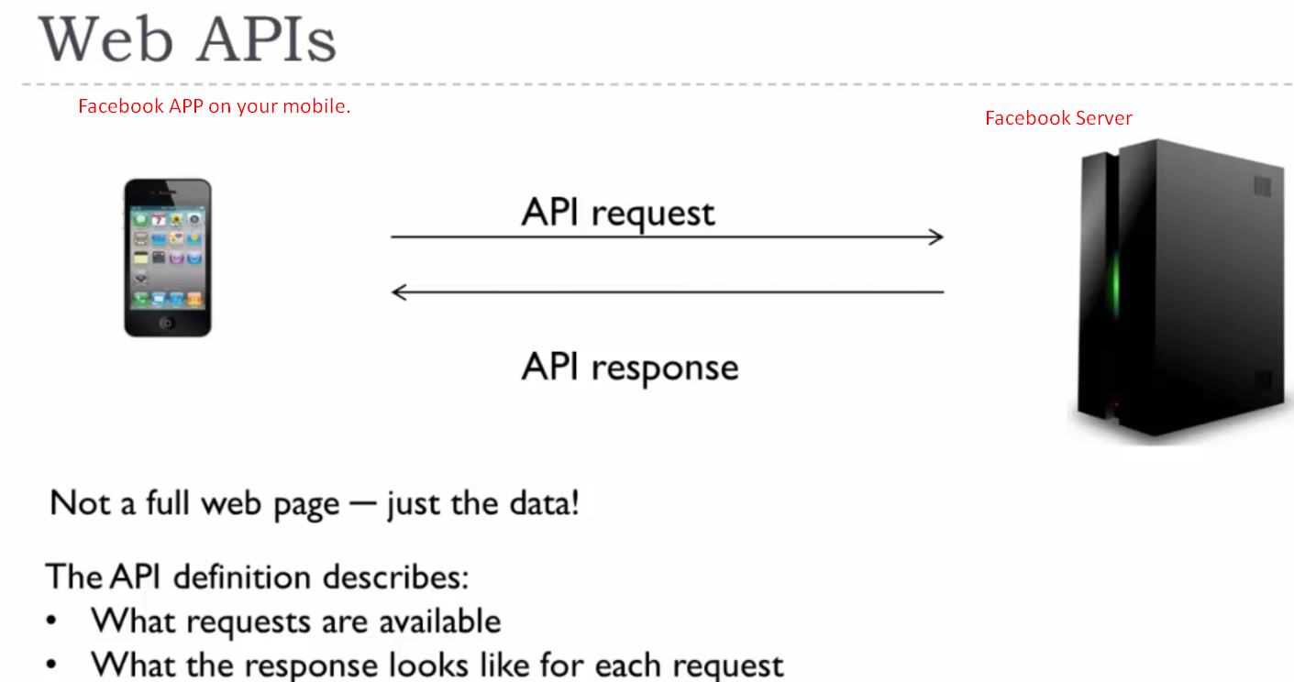
   1. Let’s say you bring up the Facebook App on your mobile.
   2. It will make API request to Facebook Server to get your feed data.
   3. The facebook server returns a response with the info to display.
7. 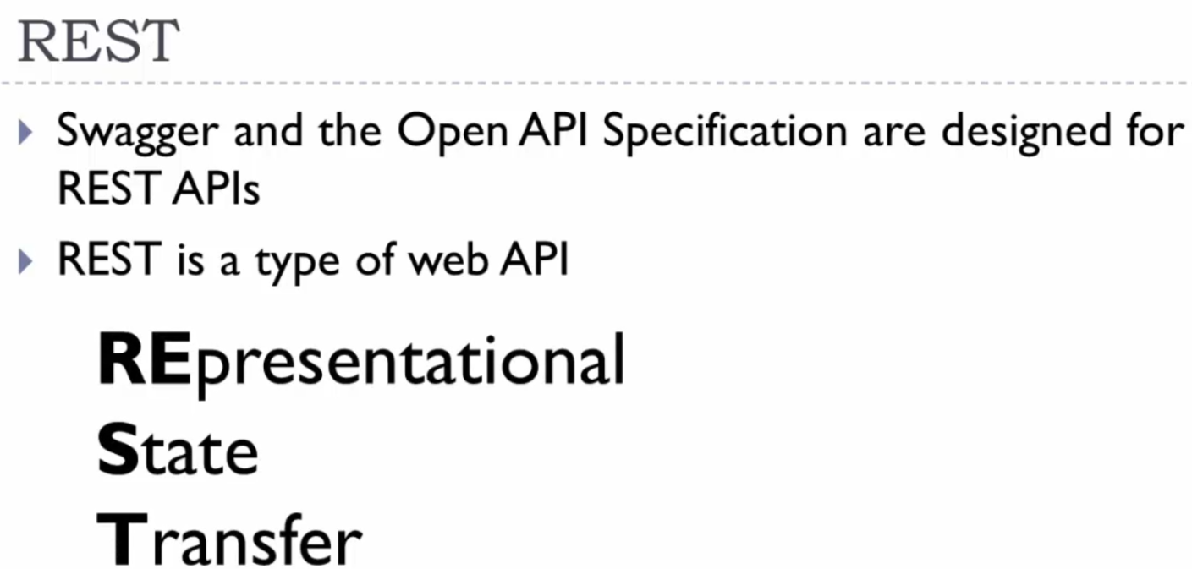
8. What does that mean, you might be wondering?
9. Let’s go back to Facebook web example.
10. 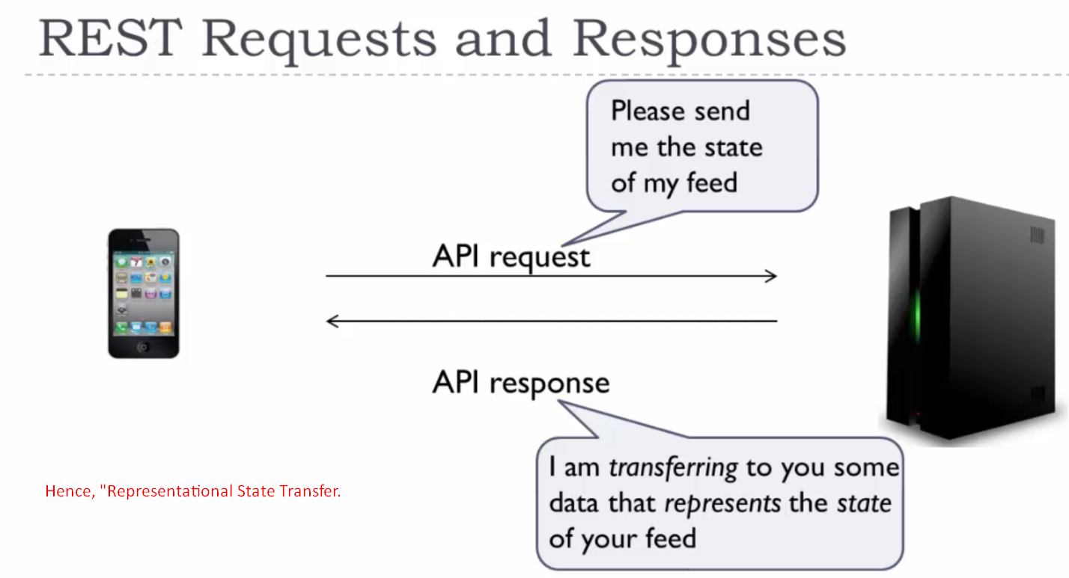
11. 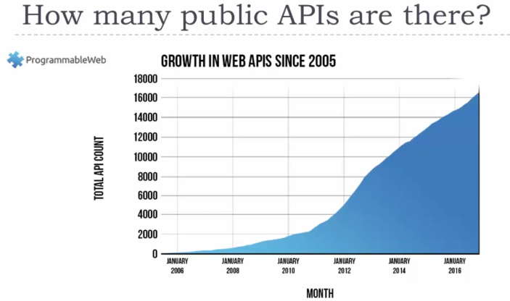  
    There is a website called “[ProgrammableWeb.com](https://www.programmableweb.com/)” that keeps track of all of the Web APIs that are publicly available to use, starting with the first API in 2005 that came from eBay.  
    You can see the extreme growth up through 2016. Managing all of these APIs is difficult.   
    By creating API definitions you can handle a lot of API-related tasks automatically.
12. 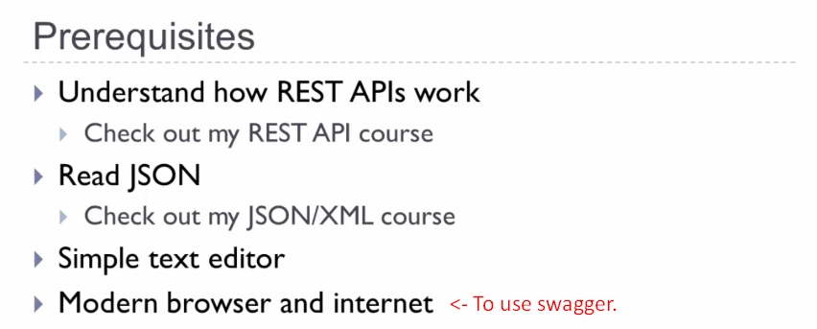
13. **What is API Specification**?  
    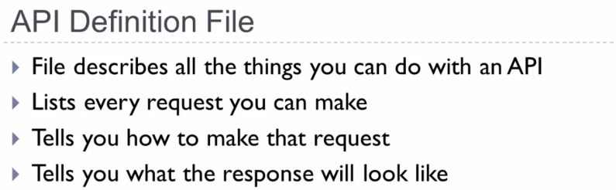
    1. It is a file that describes all of the things that you can do with an API.
14. **Why Create an API Definition**?  
    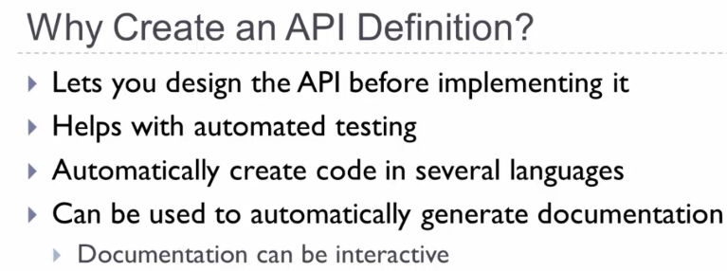
    1. **Lets you design the API before implementing it.**
       1. This is a good practice overall and others can review the API before you write the code behind it.
    2. **Helps with automated testing**.
       1. Since it’s described in **machine-readable** fashion (how to make the APIs calls).
    3. **Document**:
       1. Document can be more than just a document as you can actually try making the API calls from within the documentation.
15. 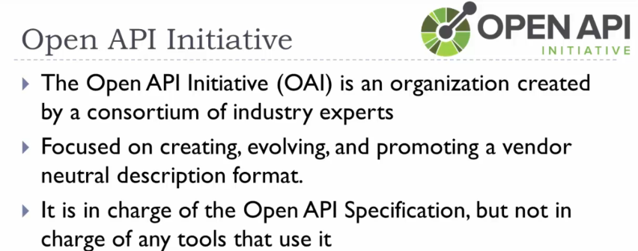
16. 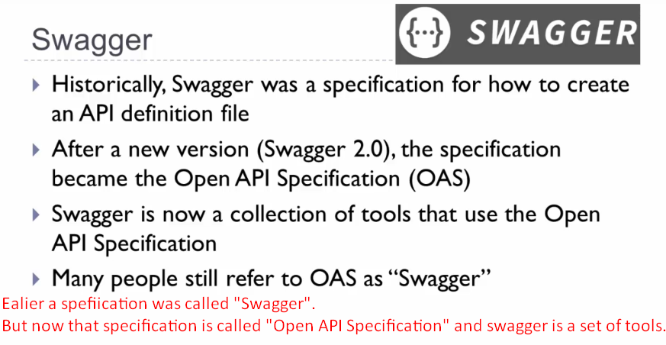
17. 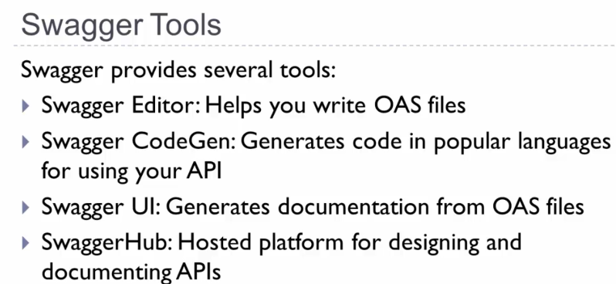
18. Let’s take a quick look at some sample documentation that Swagger generated.
19. The following is a swagger demo. It’s called Swagger Pet Store and basically it is a database of pet store information. 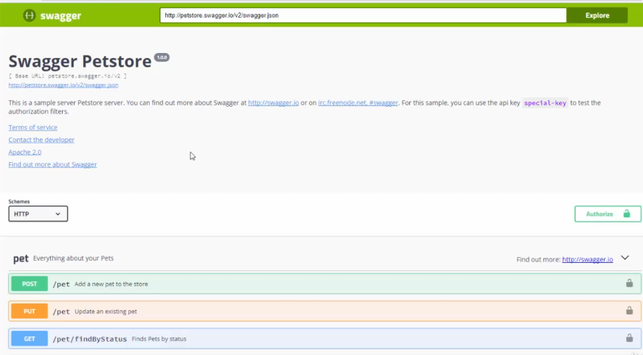
20. 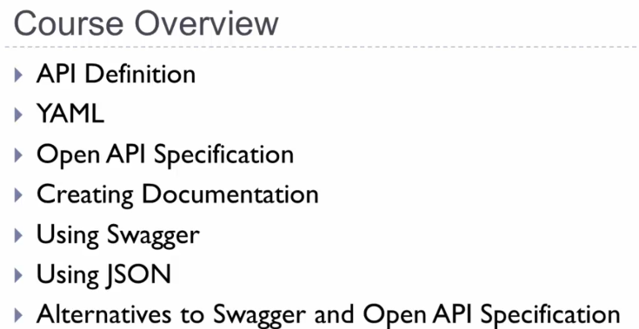
21. **Terms**: API Defintion File.